**Life Cycle Analysis and WEF Framework for Sustainable Agricultural Waste Management and Land Use Optimization under Extreme Weather Conditions Using GIS and Machine Learning**

### **Jianwei Deng**

Geoinformatics Engineering，Politechnico di Milano，Milano 20133，Italy

Email：[jianwei.deng@mail.polimi.it](mailto:jianwei.deng@mail.polimi.it)

**Abstract：**The intensifying impact of extreme weather events has raised critical concerns regarding the sustainability of agricultural systems,particularly land use practices.This research integrates Geographic Information Systems (GIS), machine learning, and Life Cycle Assessment (LCA) to address sustainable agricultural waste management and land optimization under extreme weather conditions.Utilizing the Water-Energy-Food (WEF) nexus framework, the research assesses land use practices and waste management strategies during extreme weather events like landslides. Furthermore, it investigates how machine learning can enhance predicting, managing, and optimizing of land use practices, mitigating risks such as soil erosion and resource degradation. This study offers a comprehensive approach to advancing sustainable agricultural practices in the context of climate change and extreme weather challenges.

**Keywords**：Life Cycle Assessment；Geographic Information System；Machine Learning；WEF Nexus；Sustainable Agricultural Waste Management；Extreme Weather Conditions；Land Use Optimization;

### **Introduction**

Extreme Weather Events（EWEs),such as floods, droughts, and heatwaves, are increasingly threatening agricultural systems worldwide. These events disrupt crop production, reduce soil fertility, and increase the complexity of agricultural waste management. Additionally, Extreme weather events often lead to secondary disasters such as landslides, which further exacerbate soil erosion and degrade agricultural ecosystems, posing significant challenges to sustainable resource management.The intensifying impact of EWEs has raised critical concerns about the long-term sustainability of agricultural practices, particularly in land use and waste management strategies.

Agricultural waste, when properly managed, plays a vital role in mitigating the impacts of extreme weather. For example, composting can enhance soil structure, reduce erosion, and improve water retention, thus increasing soil resilience during droughts and heavy rains. Similarly, the conversion of agricultural waste into bioenergy not only reduces greenhouse gas emissions but also helps manage waste in disaster-prone areas, decreasing the risk of landslides and improving soil stability. On the other hand, improperly managed agricultural waste may exacerbate soil erosion, soil compaction, and water runoff, which can worsen the effects of extreme weather. Despite these potential benefits, the integration of waste management strategies into land use optimization under extreme weather events remains underexplored

The impact of landslides on farmland ecosystems highlights critical gaps in understanding how to optimize land use and waste management in disaster-prone areas. Effective solutions require integrating tools such as Life Cycle Assessment (LCA) to evaluate environmental impacts, Geographic Information Systems (GIS) for spatial analysis, and machine learning for predictive modeling. However, current studies often treat these components in isolation, lacking a unified framework that addresses the compounding effects of Extreme weather events.While LCA, GIS, and machine learning have demonstrated potential in addressing individual aspects of agricultural sustainability, their integration into a unified framework to assess the compounded impacts of extreme weather events remains underexplored. Despite the recognized value of the Water-Energy-Food (WEF) nexus, its application in optimizing agricultural practices under extreme weather conditions has yet to be fully realized.

To address these gaps, this research aims to analyze and optimize agricultural waste management and land use strategies under Extreme weather events by integrating LCA, GIS, and machine learning within the WEF nexus framework. Specifically, the research will focus on:  
i) Evaluating the environmental impacts of agricultural waste and land use in the context of EWEs;  
ii) Analyzing the role of landslides in disrupting resource management and agricultural sustainability;  
iii) Developing predictive and optimization models to enhance agricultural resilience to EWEs.

By bridging these gaps, this research seeks to advance sustainable agricultural practices and provide actionable insights for mitigating the impacts of EWEs on farmland ecosystems.In the process, it offers a holistic approach to enhancing agricultural resilience and sustainability, with a focus on mitigating the combined impacts of extreme weather on land use and waste management practices.

### **Research Questions**

1. Sustainability under Extreme Weather and the WEF Nexus:

Assess the impact of extreme weather on resource management within the Water-Energy-Food (WEF) nexus in agricultural systems,focusing on the role of agricultural waste in mitigating or exacerbating soil erosion, landslides, and agricultural productivity. How can strategies like composting and bioenergy production enhance resilience under extreme conditions?

2.Life Cycle Impacts on Agricultural Practices under Extreme Weather:

How do extreme weather events impact agricultural production life cycles, and how can GIS-LCA models be used to optimize waste valorization strategies (e.g., composting or bioenergy) and mitigating resource degradation. How does agricultural waste management contribute to the long-term sustainability of soil and resource utilization in the face of extreme weather conditions?

3.Greenhouse Gas and Pollutant Emissions under Extreme Weather:

Quantify emissions and pollutant outputs,such as methane and nitrogen oxides,under extreme weather scenarios,and evaluate how agricultural waste management strategies (e.g., composting, bioenergy production, soil amendment) can reduce emissions while enhancing resource efficiency. How do these strategies mitigate the impact of extreme weather on soil quality and crop resilience?

1. Machine Learning for Waste and Land Optimization:

Apply machine learning to predict the impacts of different agricultural waste management strategies on land health indicators (e.g., soil erosion, fertility, carbon sequestration), optimizing agricultural land use and resilience to extreme weather events.and how can real-time monitoring using multi-source data (e.g., remote sensing, meteorological inputs) dynamically assess agricultural waste management systems' impacts on soil and extreme weather resilience?

**·** Predic**tive Modeling: Estimating the effects of agricultural waste management practices,**

**on soil fertility, including erosion rates, and overall land health under extreme weather conditions.**

**· Risk Assessment: Identifying regions susceptible of the machine learning models to degradation or instability, such as landslide risks exacerbated by waste accumulation or poor land use practices.**

**·Real-Time Monitoring: Integrating multi-source data (e.g:remote sensing, meteorological**

**inputs) to dynamically assess the real-time impacts of agricultural waste management systems on soil and extreme weather resilience**.

1. Landslide Risk and Agricultural Ecos**ystem Stability:**

**Investigate What role does agricultural waste management play in influencing the susceptibility of farmland to landslides under extreme weather conditions? How can waste management strategies, such as composting or bioenergy production, improve soil stability and ecosystem resilience in disaster-prone areas?**

### **Interdependencies between Waste Management, Soil Health, and Resilience** **How do agricultural waste management strategies influence the interdependencies between soil health, nutrient cycling, and resilience to extreme weather events like floods, droughts, and landslides? How can sustainable waste management practices improve soil health and agricultural system stability during these extreme conditions?**

### **Research Originality**

1.This research takes a novel approach by integrating agricultural waste management and landslide risk analysis in the context of extreme weather conditions. Unlike studies that address waste management or landslide prediction in isolation, it explores how agricultural waste valorization can simultaneously mitigate environmental risks and optimize land use. By combining environmental impact assessments with geospatial risk analysis, it establishes a comprehensive framework that enhances sustainable land-use practices under extreme weather conditions.

2.Methodologically, this research innovatively integrates GIS, machine learning, and lifecycle assessment (LCA). GIS enables spatial analysis of land use and waste management, while machine learning algorithms (e.g., random forests or support vector machines) enhance landslide risk modeling by identifying key factors and predicting risks. Additionally, LCA is adapted to incorporate temporal changes, providing a comprehensive evaluation of the long-term environmental benefits of agricultural waste management,particularly under fluctuating extreme weather conditions.The integration of these methods represents a novel approach in agricultural sustainability studies, where data-driven modeling techniques are combined to address the compounded impacts of extreme weather events. This unique combination allows for more accurate and actionable predictions for land use optimization and waste management strategies under extreme conditions, filling a critical gap in current research that typically addresses these components in isolation.

However,Implementing this integrated framework faces several challenges. Combining large datasets from sources like remote sensing and weather data can lead to issues with data quality and consistency. Additionally, the cost of advanced machine learning models and the scalability of GIS-based tools across different regions might limit their widespread use. Gaining support from stakeholders, such as farmers and policymakers, may also be challenging due to concerns about costs, technical complexity, and the need for training to use these tools effectively.

3.A key strength of this research is its use of diverse data sources, including remote sensing, meteorological data, and agricultural statistics, to build a detailed spatial database. By combining these datasets, it simulates agricultural waste management strategies and their impact on land use and landslide risks. Scenario-based modeling with extreme weather projections adds further depth, offering practical insights for sustainable land-use planning under future climate conditions.

4.The combination of GIS, LCA, and machine learning to model agricultural waste and environmental risks in extreme weather contexts represents a significant gap in current research. By filling this gap, the study offers practical solutions for enhancing the sustainability and resilience of agricultural systems in the face of climate change. Additionally, the findings could inform agricultural and environmental policy decisions, encouraging the adoption of more sustainable and resilient waste management practices.

### **Research Methodology**

**1.Overview of Methods and Techniques:**

This research integrates GIS for spatial analysis, LCA for environmental impact assessment, and machine learning for predictive modeling to address the impacts of extreme weather on agricultural systems. GIS will identify spatial patterns of waste distribution, vulnerable regions, and provide land vulnerability maps. These GIS outputs will directly inform machine learning models by providing critical spatial data for predicting landslide risk and assessing the environmental impact of different waste management strategies. LCA will provide a lifecycle perspective on resource efficiency and environmental trade-offs of waste management strategies under varying extreme weather scenarios. Machine learning will predict the effects of these strategies and weather events on soil stability. The integration of these tools offers a comprehensive approach to addressing the complex challenges posed by extreme weather events.

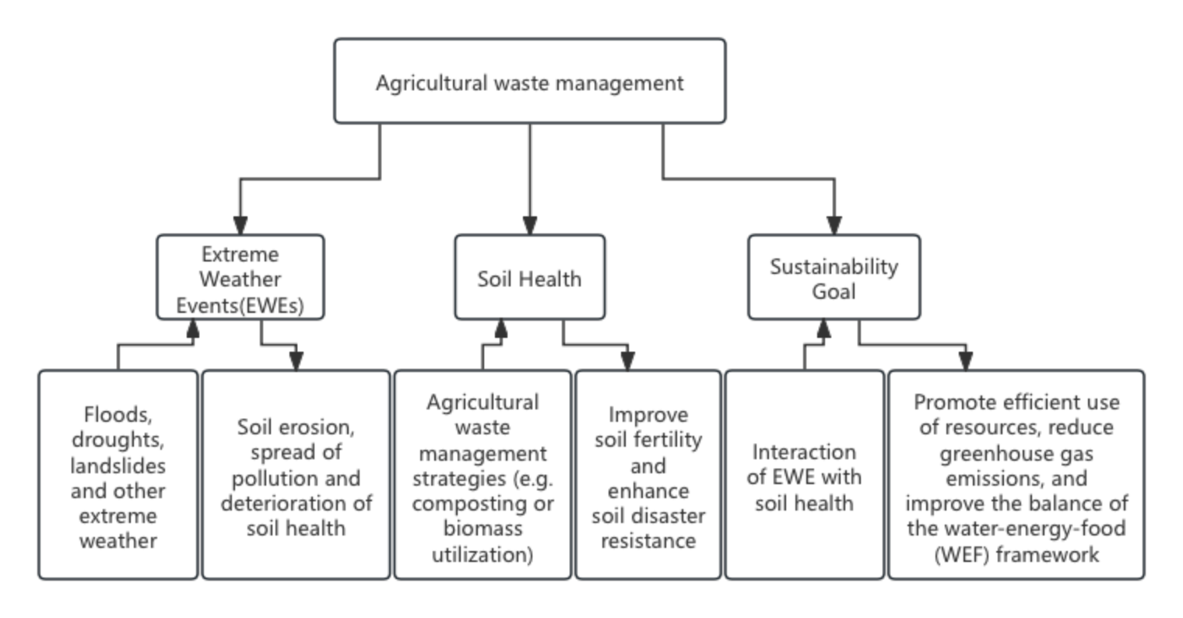

**Figure：the relationship between agricultural waste, extreme weather, soil health and sustainability goals**

**2.Data and Equipment:**

Data sources include high-resolution satellite imagery, agricultural production data, and historical meteorological data (e.g., flood intensity and drought records), and historical weather events. GIS will provide spatial outputs like land vulnerability maps and waste distribution patterns. These GIS outputs will serve as input features for machine learning models, allowing predictions for landslide risks and waste management outcomes. Computational resources such as high-performance servers will facilitate data processing and model training. Tools like ArcGIS, Python, and specialized LCA software (e.g., OpenLCA) will be used for data integration, spatial analysis, and lifecycle assessment.

**3.Theoretical Frameworks:**

The research leverages the WEF nexus to understand resource interconnections, LCA for

lifecycle-oriented analysis, and machine learning for adaptive, data-driven predictions. These

frameworks provide a multidimensional approach to understanding how extreme weather impacts

agricultural systems and guide decision-making for sustainable practices. The machine learning

component will be informed by GIS outputs, such as spatial waste distribution and land vulnerability,

enabling more accurate predictions under diverse weather conditions.

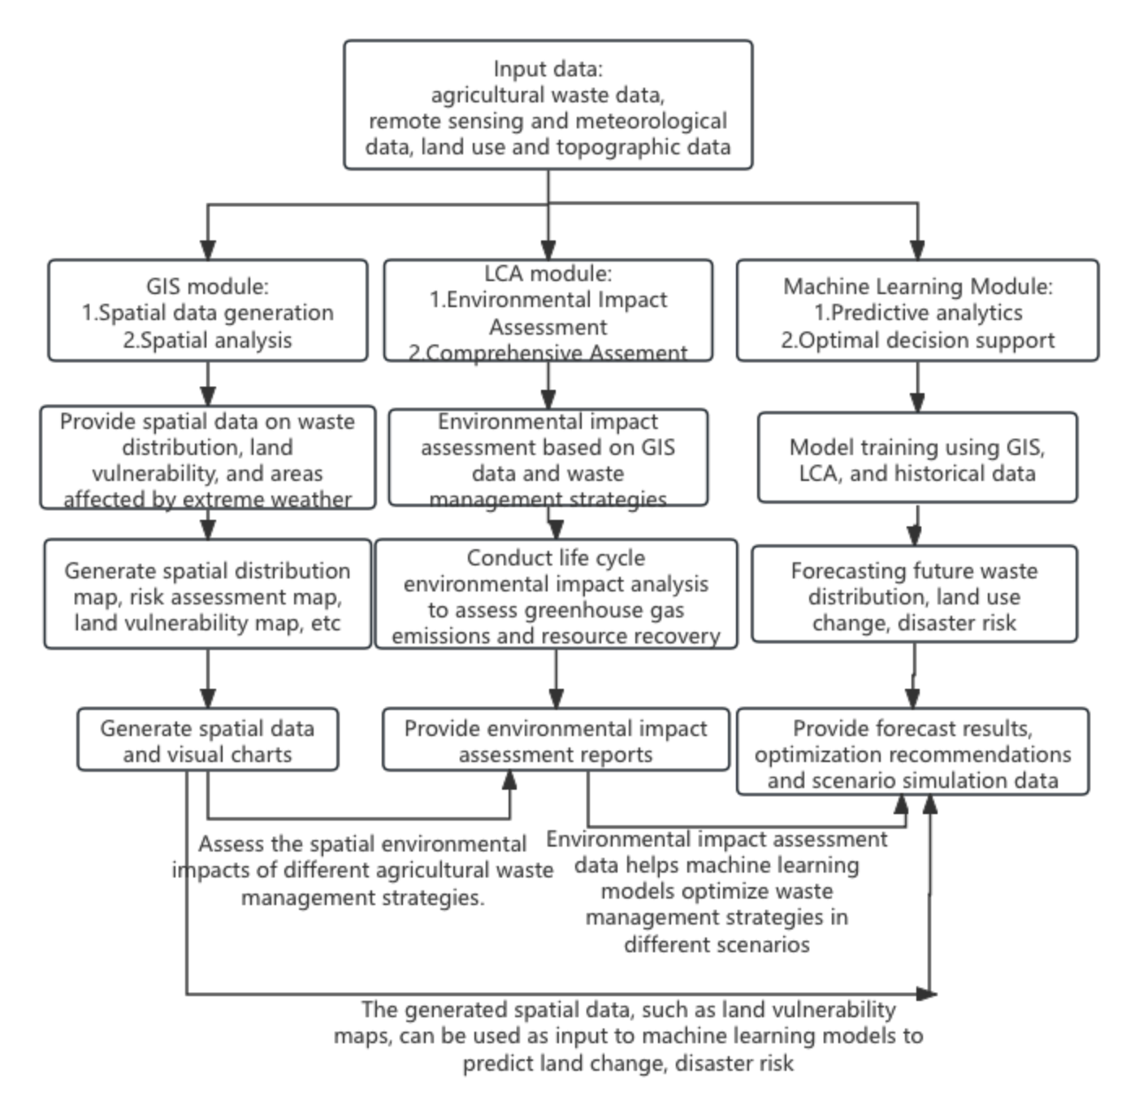

**Figure：GIS, LCA, machine learning interaction flow chart**

**4.Rationale for Method Selection:**

GIS is indispensable for capturing spatial variability, while LCA offers a structured approach to quantifying environmental impacts. Machine learning is well-suited for uncovering complex patterns and forecasting risks under extreme weather conditions. Alternative methods, such as regression-based models, lack the flexible and predictive under dynamic and uncertain conditions for dynamic scenarios.

**5.Limitations and Feasibility:**

To validate the models, real-world case studies and historical data on extreme weather events will be used. This includes

·Comparing model predictions with actual observed outcomes (e.g., landslide incidents, crop yield changes under drought conditions).

·Conducting scenario-based simulations to test the models under varying extreme weather conditions, such as floods, droughts, and heatwaves, across different geographical regions and time frames.

The main limitations include potential data gaps, such as incomplete records of historical weather events or agricultural waste data, and the high computational cost of running large-scale machine learning models. These challenges will be mitigated by:

·Selecting validated data sources and employing advanced data cleaning techniques.

·Utilizing scalable computational resources to support extensive data processing.

**6. Ethical Considerations**

To address ethical concerns:

·Data privacy will be ensured through transparent methodologies, anonymized datasets, and adherence to open-source practices.

·Collaborations with institutional partners will include ethical reviews and compliance with data usage agreements to maintain the integrity of the research process.

**7.General Resources:**

The research will rely on:

·Collaborations with national meteorological agencies, agricultural ministries, and academic institutions for data access and validation.

·Institutional support for computational resources and access to tools such as ArcGIS, OpenLCA, and Python libraries.

·Expertise from interdisciplinary teams in GIS, LCA, and machine learning to ensure methodological rigor and innovation

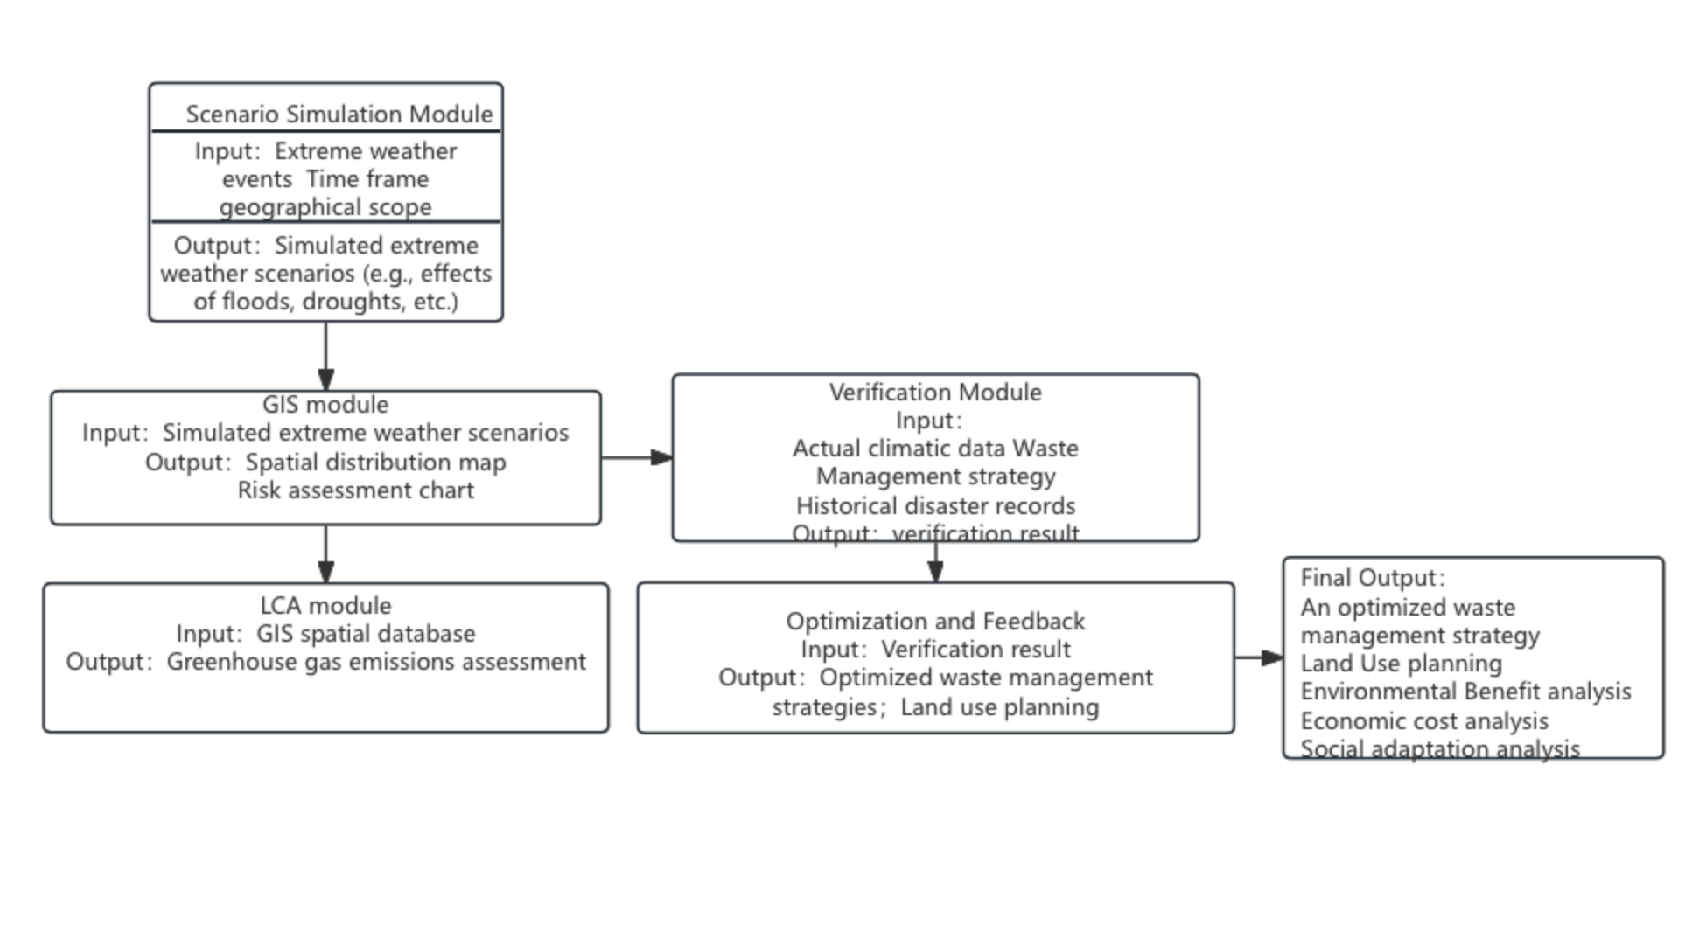

**Figure：Frame diagram of scenario simulation design and verification**

### **Expected Outcomes**

The research is anticipated to produce several significant outputs.During the course of the study, there is scope for papers addressing the following topics:

**1.GIS Maps and Decision-Support Tools for Sustainable Agricultural Systems:**

A comprehensive paper on how GIS and LCA methodologies can be combined to evaluate the environmental impacts of agricultural waste management strategies under extreme weather conditions. These maps will serve as decision-support tools for policymakers, farmers, and environmental groups, guiding sustainable resource optimization and land use planning in vulnerable regions.

**2.Machine Learning Applications in Landslide Risk and Agricultural Waste Management:**

A detailed study exploring the use of machine learning algorithms to enhance predictive accuracy in landslide susceptibility modeling and agricultural waste valorization.These models will enhance the accuracy of risk assessments, providing clear recommendations for regions prone to landslides or extreme weather events. A comparative study on algorithm performance will be included, demonstrating how machine learning can improve environmental risk prediction.

**3.Scenario-Based Modeling for Sustainable Land Use and Resource Management**

A paper focusing on scenario-based analysis that integrates extreme weather projections, assessing the implications for agricultural land-use planning and resource management. The paper would highlight innovative methods and practical outcomes for policymakers.

**4.Actionable Insights for Stakeholders:**

Based on the scenario-based modeling, this research will offer region-specific recommendations for mitigating the impacts of extreme weather on agricultural systems. This will include advice on waste management strategies (e.g., composting, bioenergy production) that can enhance soil resilience and reduce greenhouse gas emissions, tailored to specific regions or crop types.

**5.Contributions to Academic Knowledge:**

The research will advance academic understanding, particularly in the interdisciplinary fields of GIS, LCA, and machine learning. It will demonstrate how these methodologies can be combined to assess and optimize agricultural practices under extreme weather events, contributing to the growing body of knowledge on sustainable agriculture and climate adaptation strategies.

### **Completion Plan**

**Phase 1 (Months 1-8):**

· Literature Review and Review Article: Complete a comprehensive review of existing research on the impact of extreme weather on agriculture and the integration of GIS, LCA, and machine learning in agricultural waste management. Submit and publish the review article by the end of the year.

· Data Collection and Preliminary Analysis: Begin collecting remote sensing, agricultural, meteorological, and geospatial data. Start preliminary data analysis to understand the patterns of extreme weather impacts.

· Development of Methodology: Finalize the research methodology, including the design of GIS-based models and the selection of machine learning algorithms for landslide risk prediction.

**Phase 2 (Months 8-16):**

· Model Development and Integration: Develop GIS models for spatial analysis and integrate them with LCA for environmental impact evaluation. Start training machine learning models to predict landslide risks and waste management outcomes.

· Data Analysis and Testing: Continue detailed analysis of data sets and refine models based on initial findings. Test the models in various scenarios to ensure their accuracy in predicting extreme weather impacts.

· Prepare Draft for Paper on Model Integration: Start drafting a research paper on the integrated methodology for waste management, landslide risk prediction, and resource optimization in extreme weather scenarios.

**Phase 3 (Months 16-24):**

· Final Model Refinement and Testing: Refine the predictive models and finalize their integration with GIS and LCA. Conduct final tests to validate the models and assess their performance.

· Scenario-based Testing and Optimization: Conduct scenario-based simulations to test the impact of different agricultural waste management strategies under extreme weather conditions.

· Finalize Papers for Publication: Finalize research papers based on the developed models, results, and scenario analyses for submission to high-impact journals in the fields of agriculture, GIS, and environmental science.

· Thesis Writing: Complete the thesis, summarizing all findings, methodologies, and papers.Ensure that the thesis integrates the outcomes of the model development, scenario-based testing, and proposed policy recommendations.

**Summary**

This research proposal integrates GIS, machine learning, and life cycle assessment (LCA) to assess the impact of extreme weather events on agricultural systems. It focuses on optimizing agricultural waste management and enhancing resource recovery.By utilizing remote sensing, meteorological data, and GIS for spatial analysis, the study simulates various waste management scenarios and assesses their influence on soil stability and landslide risks under extreme weather conditions. the study aims to develop predictive models that inform land use planning and waste management strategies, providing actionable insights for improving the resilience and sustainability of agricultural practices in the face of climate change. Additionally, the study seeks to offer practical decision-support tools, such as GIS maps and machine learning models, that can guide policymakers, farmers, and environmental groups in adapting to future climate challenges. Ultimately, this integrated approach fills a critical gap in current research and provides a comprehensive framework for advancing sustainable agriculture under extreme weather conditions.

**References**

Mancuso, G., Parlato, M., Lavrnic, S., Toscano, A., Valenti, F. (2022). GIS-Based Assessment of the Potential for Treated Wastewater Reuse in Agricultural Irrigation: A Case Study in Northern Italy. SUSTAINABILITY, 14(15), 1-17

[https://dx.doi.org/10.3390/su14159364](https://dx.doi.org/10.3390/su14159364" \t "/Users/ignacio/Documents\\x/_blank)

Valenti F., Toscano A. (2021). A gis-based model to assess the potential of wastewater treatment plants for enhancing bioenergy production within the context of the water–energy nexus. ENERGIES, 14(10), 1-15 [10.3390/en14102838].

[https://dx.doi.org/10.3390/en14102838](https://dx.doi.org/10.3390/en14102838" \t "/Users/ignacio/Documents\\x/_blank)

Peng Chen, Biao Wang, Yanlan Wu, Qijun Wang, Zuoji Huang, Chunlin Wang,

Urban river water quality monitoring based on self-optimizing machine learning method using multi-source remote sensing data,

Ecological Indicators,Volume 146,2023,109750,ISSN1470-160X,

<https://doi.org/10.1016/j.ecolind.2022.109750.>

ohsen Mandegari, Mahmood Ebadian, Jack (John) Saddler,

The need for effective life cycle assessment (LCA) to enhance the effectiveness of policies such as low carbon fuel standards (LCFS's),Energy Policy,Volume 181,2023,113723,ISSN 0301-4215,

<https://doi.org/10.1016/j.enpol.2023.113723.>

Wanyu Pei, Filip Biljecki, Rudi Stouffs,

Techniques and tools for integrating building material stock analysis and life cycle assessment at the urban scale: A systematic literature review,Building and Environment,Volume 262,2024,111741,ISSN 0360-1323,

<https://doi.org/10.1016/j.buildenv.2024.111741.>

Guanhan Zhao, Peng Jiang, Hao Zhang, Lin Li, Tuo Ji, Liwen Mu, Xiaohua Lu, Jiahua Zhu,

Mapping out the regional low-carbon and economic biomass supply chain by aligning geographic information systems and life cycle assessment models,Applied Energy,Volume 369,2024,123599,ISSN 0306-2619,

<https://doi.org/10.1016/j.apenergy.2024.123599.>

Yuanliang Jin, David O'Connor, Ping Du, Muhan Qin, Bin Zhao, Chengshuai Liu, Deyi Hou,

Life cycle assessment to unravel environmental benefits and influencing factors of agricultural soil remediation strategies in China,

Resources, Conservation and Recycling,Volume 211,2024,107850,ISSN 0921-3449,

<https://doi.org/10.1016/j.resconrec.2024.107850.>

Sergio García-Pérez, Jorge Sierra-Pérez, Jesús Boschmonart-Rives,

Environmental assessment at the urban level combining LCA-GIS methodologies: A case research of energy retrofits in the Barcelona metropolitan area,

Building and Environment,Volume 134,2018,Pages 191-204,ISSN 0360-1323,

<https://doi.org/10.1016/j.buildenv.2018.01.041.>

Laisa Matagi, Delmaria Richards, Helmut Yabar, Takeshi Mizunoya, Gia Hong Tran, Christian Toochukwu Ogbonna,

Enhancing Solid Waste Management in Fiji: A Comprehensive Approach with LCA, GIS, and Waste Treatment Strategies,Resources,

Conservation & Recycling Advances,Volume 23,2024,200228,ISSN 2667-3789,

<https://doi.org/10.1016/j.rcradv.2024.200228.>

Yuqiong Long, Qingbin Song, Beijia Huang, Xianlai Zeng, Huanyu Wu,

Characterizing temporal and spatial characteristics of urban building material metabolism and embodied carbon emissions through a 4D GIS-MFA-LCA model,

Resources, Conservation and Recycling,Volume 206,2024,107642,ISSN 0921-3449,

<https://doi.org/10.1016/j.resconrec.2024.107642.>

Graham A. McAuliffe, Yusheng Zhang, Adrian L. Collins,

Assessing catchment scale water quality of agri-food systems and the scope for reducing unintended consequences using spatial life cycle assessment (LCA),

Journal of Environmental Management,Volume 318,2022,115563,ISSN 0301-4797,

<https://doi.org/10.1016/j.jenvman.2022.115563.>

Carles M. Gasol, Xavier Gabarrell, Miquel Rigola, Sara González-García, Joan Rieradevall,

Environmental assessment: (LCA) and spatial modelling (GIS) of energy crop implementation on local scale,

Biomass and Bioenergy,Volume 35, Issue 7,2011,Pages 2975-2985,ISSN 0961-9534,

<https://doi.org/10.1016/j.biombioe.2011.03.041.>

Lishan Xiao, Weiyue Li, Leji Dong, Xian Wu, Hong Ye,

Characterizing spatiotemporal dynamics of carbon emissions in peri-urban residential communities: A life cycle perspective,

Journal of Cleaner Production,Volume 448,2024,141613,ISSN 0959-6526,

<https://doi.org/10.1016/j.jclepro.2024.141613.>

Vivek Ojha, Apurva Sharma, Ved Prakash Ranjan, Rahul Rautela, Aachal Dhawral, Sunil Kumar,

Resource recovery from legacy waste dumpsites in India: A path towards sustainable waste management,

Chemosphere,Volume 365,2024,143337,ISSN 0045-6535,

<https://doi.org/10.1016/j.chemosphere.2024.143337.>

Hyuni Jung, Giyoung Shin, Sung Bae Park, Jonggeon Jegal, Seul-A Park, Jeyoung Park, Dongyeop X. Oh, Hyo Jeong Kim,

Circular waste management: Superworms as a sustainable solution for biodegradable plastic degradation and resource recovery,

Waste Management,Volume 171,2023,Pages 568-579,ISSN 0956-053X,

<https://doi.org/10.1016/j.wasman.2023.09.027.>

A. Saravanan, Ponnusamy Senthil Kumar, Tran Cam Nhung, B. Ramesh, S. Srinivasan, Gayathri Rangasamy,

A review on biological methodologies in municipal solid waste management and landfilling: Resource and energy recovery,

Chemosphere,Volume 309, Part 1,2022,136630,ISSN 0045-6535,

[https://doi.org/10.1016/j.chemosphere.2022.136630.(https://www.sciencedirect.com/science/article/pii/S004565352203123X)](https://doi.org/10.1016/j.chemosphere.2022.136630.(https:/www.sciencedirect.com/science/article/pii/S004565352203123X))

Seyed Hamidreza Ghaffar, Matthew Burman, Nuhu Braimah,

Pathways to circular construction: An integrated management of construction and demolition waste for resource recovery,

Journal of Cleaner Production,Volume 244,2020,118710,ISSN 0959-6526,

[https://doi.org/10.1016/j.jclepro.2019.118710.(https://www.sciencedirect.com/science/article/pii/S0959652619335802)](https://doi.org/10.1016/j.jclepro.2019.118710.(https:/www.sciencedirect.com/science/article/pii/S0959652619335802))

Tianran Ding, Bernhard Steubing, Wouter M.J. Achten,

Coupling optimization with territorial LCA to support agricultural land-use planning,

Journal of Environmental Management,Volume 328,2023,116946,ISSN 0301-4797,

[https://doi.org/10.1016/j.jenvman.2022.116946.(https://www.sciencedirect.com/science/article/pii/S0301479722025191)](https://doi.org/10.1016/j.jenvman.2022.116946.(https:/www.sciencedirect.com/science/article/pii/S0301479722025191))

Giuseppe Pulighe, Tiziana Pirelli,

Assessing the sustainability of bioenergy pathways through a land-water-energy nexus approach,

Renewable and Sustainable Energy Reviews,

Volume 184,2023,113539,ISSN 1364-0321,

[https://doi.org/10.1016/j.rser.2023.113539.(https://www.sciencedirect.com/science/article/pii/S1364032123003969)](https://doi.org/10.1016/j.rser.2023.113539.(https:/www.sciencedirect.com/science/article/pii/S1364032123003969))

Hossein Nematollahi, Saeid Gitipour, Nasser Mehrdadi,

Comparative life cycle assessment and route optimization modeling of smart versus conventional municipal waste collection: Environmental impact analysis in an urban context,

Results in Engineering,Volume 24,2024,103408,ISSN 2590-1230,

[https://doi.org/10.1016/j.rineng.2024.103408.(https://www.sciencedirect.com/science/article/pii/S2590123024016608)](https://doi.org/10.1016/j.rineng.2024.103408.(https:/www.sciencedirect.com/science/article/pii/S2590123024016608))

Sara Lago-Olveira, Maria Teresa Moreira, Sara González-García,

Quantifying spatially explicit LCA midpoint characterization factors to assess the impact of specific farming practices on ecosystem services,

Ecosystem Services,Volume 71,2025,101686,ISSN 2212-0416,

[https://doi.org/10.1016/j.ecoser.2024.101686.(https://www.sciencedirect.com/science/article/pii/S2212041624000937)](https://doi.org/10.1016/j.ecoser.2024.101686.(https:/www.sciencedirect.com/science/article/pii/S2212041624000937))

Laura Ferretto, Giulia Lucertini, Daniele Brigolin,

LCA for territorial metabolism analysis: An application to organic waste management planning,

Journal of Cleaner Production,Volume 441,2024,141051,ISSN 0959-6526,

[https://doi.org/10.1016/j.jclepro.2024.141051.(https://www.sciencedirect.com/science/article/pii/S0959652624004980)](https://doi.org/10.1016/j.jclepro.2024.141051.(https:/www.sciencedirect.com/science/article/pii/S0959652624004980))

Yash Aryan, Atul Kumar, Subham, Sukha Ranjan Samadder,

Environmental and economic assessment of waste collection and transportation using LCA: A case study,

Environmental Research,Volume 231, Part 2,2023,116108,ISSN 0013-9351,

[https://doi.org/10.1016/j.envres.2023.116108.(https://www.sciencedirect.com/science/article/pii/S0013935123009003)](https://doi.org/10.1016/j.envres.2023.116108.(https:/www.sciencedirect.com/science/article/pii/S0013935123009003))

Laure Nitschelm, Joël Aubin, Michael S. Corson, Valérie Viaud, Christian Walter,

Spatial differentiation in Life Cycle Assessment LCA applied to an agricultural territory: current practices and method development,

Journal of Cleaner Production,Volume 112, Part 4,2016,Pages 2472-2484,ISSN 0959-6526,

[https://doi.org/10.1016/j.jclepro.2015.09.138.(https://www.sciencedirect.com/science/article/pii/S0959652615013785)](https://doi.org/10.1016/j.jclepro.2015.09.138.(https:/www.sciencedirect.com/science/article/pii/S0959652615013785))

Suresh Chand Rai, Vijendra Kumar Pandey, Kaushal Kumar Sharma, Sanjeev Sharma,

Landslide susceptibility analysis in the Bhilangana Basin (India) using GIS-based machine learning methods,

Geosystems and Geoenvironment,Volume 3, Issue 2,2024,100253,ISSN 2772-8838,

[https://doi.org/10.1016/j.geogeo.2024.100253.(https://www.sciencedirect.com/science/article/pii/S2772883824000037)](https://doi.org/10.1016/j.geogeo.2024.100253.(https:/www.sciencedirect.com/science/article/pii/S2772883824000037))

Hai-Min Lyu, Zhen-Yu Yin, Pierre-Yves Hicher, Farid Laouafa,

Incorporating mitigation strategies in machine learning for landslide susceptibility prediction,

Geoscience Frontiers,Volume 15, Issue 5,2024,101869,ISSN 1674-9871,

[https://doi.org/10.1016/j.gsf.2024.101869.(https://www.sciencedirect.com/science/article/pii/S1674987124000938)](https://doi.org/10.1016/j.gsf.2024.101869.(https:/www.sciencedirect.com/science/article/pii/S1674987124000938))

Likinaw Mengstie, Assayew Nebere, Muralitharan Jothimani, Biniyam Taye,

Landslide susceptibility assessment in Addi Arkay, Ethiopia using GIS, remote sensing, and AHP,

Quaternary Science Advances,Volume 15,2024,100217,ISSN 2666-0334,

[https://doi.org/10.1016/j.qsa.2024.100217.(https://www.sciencedirect.com/science/article/pii/S2666033424000558)](https://doi.org/10.1016/j.qsa.2024.100217.(https:/www.sciencedirect.com/science/article/pii/S2666033424000558))

Indrajit Poddar, Ranjan Roy,

Application of GIS-based data-driven bivariate statistical models for landslide prediction: a case study of highly affected landslide prone areas of Teesta River basin,

Quaternary Science Advances,Volume 13,2024,100150,ISSN 2666-0334,

[https://doi.org/10.1016/j.qsa.2023.100150.(https://www.sciencedirect.com/science/article/pii/S2666033423000825)](https://doi.org/10.1016/j.qsa.2023.100150.(https:/www.sciencedirect.com/science/article/pii/S2666033423000825))

Shaoqiang Meng, Zhenming Shi, Gang Li, Ming Peng, Liu Liu, Hongchao Zheng, Changshi Zhou,

A novel deep learning framework for landslide susceptibility assessment using improved deep belief networks with the intelligent optimization algorithm,

Computers and Geotechnics,Volume 167,2024,106106,ISSN 0266-352X,

[https://doi.org/10.1016/j.compgeo.2024.106106.(https://www.sciencedirect.com/science/article/pii/S0266352X24000429)](https://doi.org/10.1016/j.compgeo.2024.106106.(https:/www.sciencedirect.com/science/article/pii/S0266352X24000429))

A.L. Achu, Jobin Thomas, C.D. Aju, H. Vijith, Girish Gopinath,

Redefining landslide susceptibility under extreme rainfall events using deep learning,

Geomorphology,Volume 448,2024,109033,ISSN 0169-555X,

[https://doi.org/10.1016/j.geomorph.2023.109033.(https://www.sciencedirect.com/science/article/pii/S0169555X23004531)](https://doi.org/10.1016/j.geomorph.2023.109033.(https:/www.sciencedirect.com/science/article/pii/S0169555X23004531))

Enner Alcântara, Cheila Flávia Baião, Yasmim Carvalho Guimarães, José Antonio Marengo, José Roberto Mantovani,

Climate Change-Induced Shifts in Landslide Susceptibility in São Sebastião (Southeastern Brazil),

Natural Hazards Research,2024,ISSN 2666-5921,

[https://doi.org/10.1016/j.nhres.2024.11.005.(https://www.sciencedirect.com/science/article/pii/S2666592124000921)](https://doi.org/10.1016/j.nhres.2024.11.005.(https:/www.sciencedirect.com/science/article/pii/S2666592124000921))

Riza Radmehr, B. Wade Brorsen, Samira Shayanmehr,

Adapting to climate change in arid agricultural systems: An optimization model for water-energy-food nexus sustainability,

Agricultural Water Management,Volume 303,2024,109052,ISSN 0378-3774,

[https://doi.org/10.1016/j.agwat.2024.109052.(https://www.sciencedirect.com/science/article/pii/S0378377424003871)](https://doi.org/10.1016/j.agwat.2024.109052.(https:/www.sciencedirect.com/science/article/pii/S0378377424003871))